

A REPORT ON COURSE PROJECT OF

ENGINEERING EXPLORATION

CUP CRUSHER

BY

VARUN MH-622

RAHUL AIHOLE -643

CHIDANAND-605

MAX-610

NEED STATEMENT

A canteen is planning to send its used cups to a recycled plant. The cups need to be crushed as to decrease the volume occupied during transportation. Design a low-cost solution for the same.

PROBLEM DEFINITION

This is project about finding an efficient and effective way to minimize the volume and space required by wastepaper/plastic cups. This is a problem with many solutions, and we have come up with a unique approach to solve this. The key here is to compress the entire mass of paper cups into a space as small as possible. This could be solved by applying equal pressure on all the sides of the cup mass and a hydraulic system is the most suitable solution.

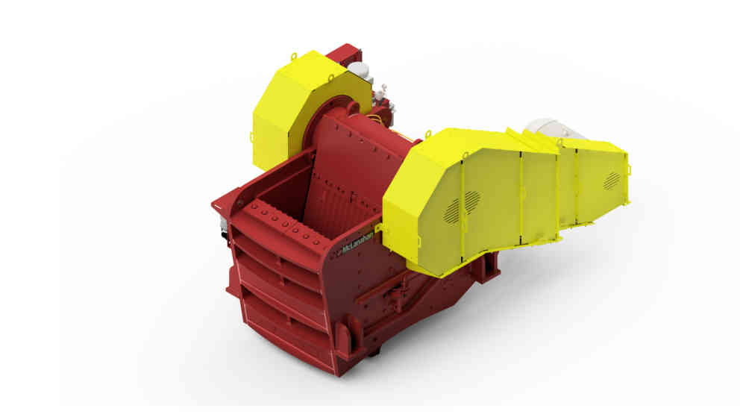

CASE STUDY :

1.NEED STATEMENT : A canteen is planning to send its used cups to a recycled plant. The cups need to be crushed as to decrease the volume occupied during transportation. Design a low-cost solution for the same.

2.DESIGNERS:

VARUN MH, RAHUL, CHIDANAND, MAX

3.CLIENTS:

CANTEEN

4.USERS:

CANTEEN

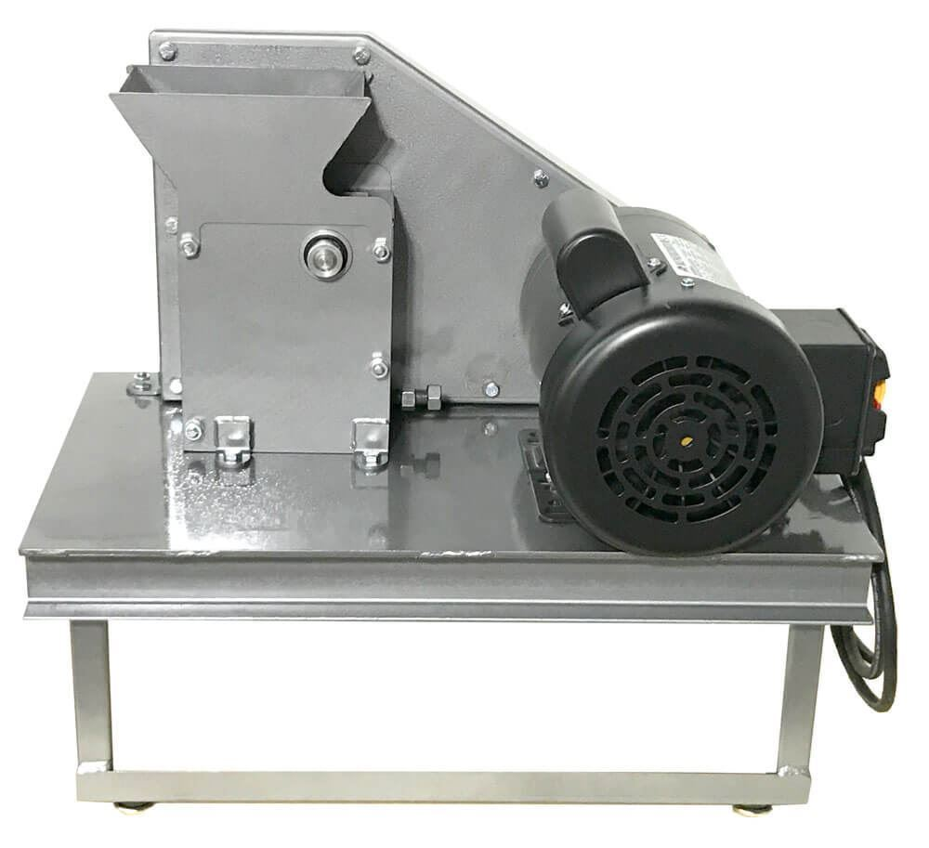

|  |  |  |  |
| --- | --- | --- | --- |
| QUESTIONS  SUCH AS | OBJECTIVES | CONSTRAINTS | FUNCTIONS |
| What should be the final cost of the  Cup crusher?  How many cups should be crushed at once?  What is the range of cup sizes that need to be crushed?  Is there a need for seperate storage for crushed cups?  Should the machine function automatically or manually?  Does the machine need to be portable?  What should be the space limit for the machine?  How much power should the machine consume?  Is there a need for a backup power source?  Should the machine be safe?  Should the machine be easy to use?  Should the machine be able to handle rough use and/or be rigid and durable?  How much should the size of the cups be reduced to? | 🗸  🗸  🗸  🗸  🗸 | 🗸  🗸  🗸    🗸 | 🗸  🗸  🗸  🗸 |

1.1- Objectives:

1. The machine should efficiently crush the cups.
2. The machine should be affordable.
3. The machine should be easy to use.
4. The machine must be Safe to use.
5. It should be durable.

1.2-PRIORITY TABLE:

|  |  |  |  |  |  |
| --- | --- | --- | --- | --- | --- |
|  | EFFICIENCY | EASY TO USE | COST | SAFETY | TOTAL |
| EFFICIENCY |   |  |  |   |  |
| EASE OF USE |     |  |  |  |  |
| COST |  |  |  |  |  |
| SAFETY |  |  |  |  |  |

Total=06

1.3-Constraints:

1. Machine should be Affordable. The cost should not exceed Rs. 5000.
2. At least 10 cups to be crushed per batch.
3. The machine should not consume more than 50 watts.
4. Machine should not be more than 2ft*2ft*2ft in size.

1.4-FUNCTIONS:

1. The machine should be able to crush a wide range of cup sizes.
2. The crushed cups must be pushed into a storage facility so that the consecutive cups be crushed properly.
3. The machine should have both automatic and manual functionality.
4. The machine should have a backup power facility so that it can work even in case of a power failure.

Revised problem definition:

Automated crushing machine is required for canteen to decrease the volume of the cups during transportation for recycling. Designing a cup crusher of high functionality,easy to handle,economically affordable,and a eco-friendly product. Make sure that the device consumes low power and requires less,easy to use,and with perfect finish. The cup crusher should be made within affordable cost,and should be easy to use,the client wants the device to be set up within a cost of 5000/ and w.r.t efficiency a minimum of 10cups should be crushed per batch ,the maximum power supply that can be supplied is of 50 watts ,the machine should be functioning within this limit of power supply and the crusher should occupy within a space of 2*2*2.

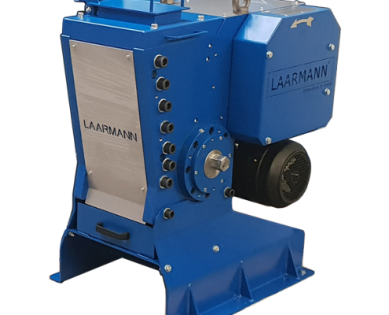

gathering Pertinent information:

History

On Jan.3, 1950 H.B. HAIT invented Cup crusher machine. His invention relates to a cup crusher and a removable wastepaper cup container and relates particularly to a crusher and removable wastepaper cup holder embodied with a water drinking fountain.

Paper cups have been used to hold water from which a person could drink water obtained from a refillable water cooler. After the cups have been used , they usually have been thrown into a container or waste paper basket, and during the time that many cups are used, as on warm days, it has been necessary to frequently clean out the waste cups; otherwise they overflow from the container. This is especially true where soft drinks are purchased from automatic dispensers and where the machine may not be serviced for a relatively long period of time and under such conditions the waste cups create a nuisance.

In industries, crushers are machine which are used to compress material into small fractional chunks or denser masses. Throughout most of industrial history, the greater part of crushing occurred under muscle power as the application of force by means of hammer and other tools. TECHNOLOGY:

For the most part advances in crusher design have moved slowly. Jaw crushers have remained virtually unchanged for sixty years. More reliability and higher production have been added to basic cone crusher designs that have also remained largely unchanged. Increases in rotating speed have provided the largest variation. For instance, a 48-inch (120 cm) cone crusher manufactured in 1960 may be able to produce 170 tons/h of crushed rock, whereas the same size crusher manufactured today may produce 300 tons/h. These production improvements come from speed increases and better crushing chamber designs.

The largest advance in cone crusher reliability has been seen in the use of hydraulics to protect crushers from being damaged when uncrushable objects enter the crushing chamber. Foreign objects, such as [steel](https://en.wikipedia.org/wiki/Steel), can cause extensive damage to a cone crusher, and additional costs in lost production. The advance of hydraulic relief systems has greatly reduced downtime and improved the life of these machines.

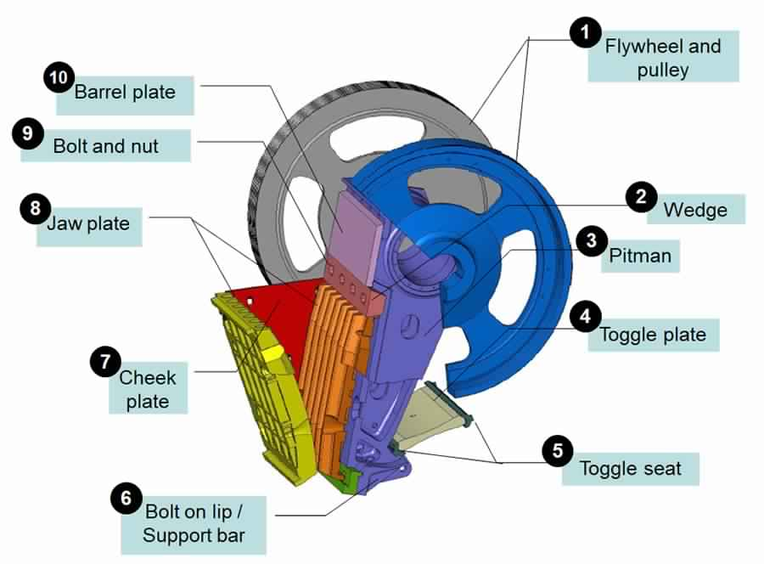

Crusher

A **crusher** is a [machine](https://en.wikipedia.org/wiki/Machine) designed to reduce large [rocks](https://en.wikipedia.org/wiki/Rock_(geology)) into smaller rocks, [gravel](https://en.wikipedia.org/wiki/Gravel), or rock dust.

Crushers may be used to reduce the size, or change the form, of waste materials so they can be more easily disposed of or [recycled](https://en.wikipedia.org/wiki/Recycled), or to reduce the size of a solid mix of raw materials (as in rock [ore](https://en.wikipedia.org/wiki/Ore)), so that pieces of different composition can be differentiated. Crushing is the process of transferring a force amplified by [mechanical advantage](https://en.wikipedia.org/wiki/Mechanical_advantage) through a material made of molecules that bond together more strongly, and resist deformation more, than those in the material being crushed do. Crushing devices hold material between two parallel or [tangent](https://en.wikipedia.org/wiki/Tangent) solid surfaces, and apply sufficient force to bring the surfaces together to generate enough energy within the material being crushed so that its molecules separate from (fracturing), or change alignment in relation to (deformation), each other. The earliest crushers were hand-held stones, where the weight of the stone provided a boost to muscle power, used against a stone anvil. [Querns](https://en.wikipedia.org/wiki/Querns) and [mortars](https://en.wikipedia.org/wiki/Mortar_and_pestle) are types of these crushin devices.

TYPES OF CRUSHER:

1.JAW CRUSHER: A jaw crusher uses compressive force for breaking of particle. This mechanical pressure is achieved by the two jaws of the crusher of which one is fixed while the other reciprocates. A jaw or toggle crusher consists of a set of vertical jaws, one jaw is kept stationary and is called a fixed jaw while the other jaw called a swing jaw, moves back and forth relative to it, by a [cam](https://en.wikipedia.org/wiki/Cam" \o "Cam) or [pitman](https://en.wikipedia.org/wiki/Connecting_rod) mechanism, acting like a class II [lever](https://en.wikipedia.org/wiki/Lever#Classes_of_levers) or a [nutcracker](https://en.wikipedia.org/wiki/Nutcracker). The volume or cavity between the two jaws is called the crushing chamber. The movement of the swing jaw can be quite small, since complete crushing is not performed in one stroke. The inertia required to crush the material is provided by a [flywheel](https://en.wikipedia.org/wiki/Flywheel) that moves a shaft creating an eccentric motion that causes the closing of the gap.

2.GYRATORY CRUSHER: A gyratory crusher is similar in basic concept to a jaw crusher, consisting of a concave surface and a conical head; both surfaces are typically lined with manganese steel surfaces. The inner cone has a slight circular movement, but does not rotate; the movement is generated by an [eccentric](https://en.wikipedia.org/wiki/Eccentric_(mechanism)) arrangement. As with the jaw crusher, material travels downward between the two surfaces being progressively crushed until it is small enough to fall out through the gap between the two surfaces.

A gyratory crusher is one of the main types of primary crushers in a mine or ore processing plant. Gyratory crushers are designated in size either by the gape and mantle diameter or by the size of the receiving opening. Gyratory crushers can be used for primary or secondary crushing. The crushing action is caused by the closing of the gap between the mantle line mounted on the central vertical spindle and the concave liners mounted on the main frame of the crusher. The gap is opened and closed by an eccentric on the bottom of the spindle that causes the central vertical spindle to gyrate. The vertical spindle is free to rotate around its own axis. The crusher illustrated is a short-shaft suspended spindle type, meaning that the main shaft is suspended at the top and that the eccentric is mounted above the gear. The short-shaft design has superseded the long-shaft design in which the eccentric is mounted below the gear.

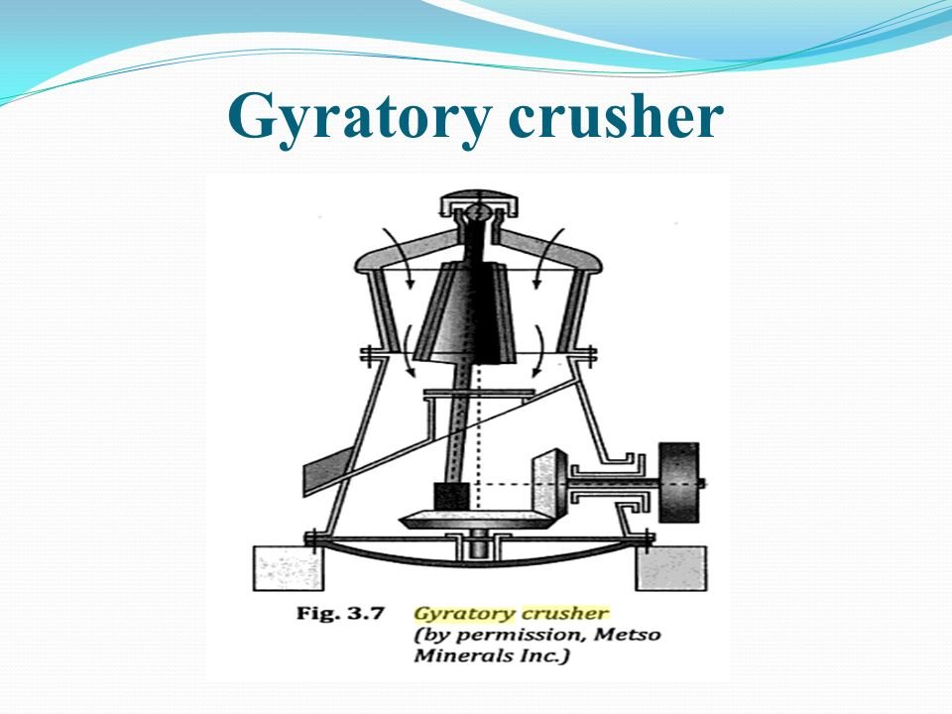

3.CONE CRUSHER: A cone crusher is similar in operation to a gyratory crusher, with less steepness in the crushing chamber and more of a parallel zone between crushing zones. A cone crusher breaks rock by squeezing the rock between an eccentrically gyrating spindle, which is covered by a wear-resistant mantle, and the enclosing concave hopper, covered by a manganese concave or a bowl liner. As rock enters the top of the cone crusher, it becomes wedged and squeezed between the mantle and the bowl liner or concave. Large pieces of ore are broken once, and then fall to a lower position (because they are now smaller) where they are broken again. This process continues until the pieces are small enough to fall through the narrow opening at the bottom of the crusher.

A cone crusher is suitable for crushing a variety of mid-hard and above mid-hard ores and rocks. It has the advantage of reliable construction, high productivity, easy adjustment and lower operational costs. The spring release system of a cone crusher acts an overload protection that allows tramp to pass through the crushing chamber without damage to the crusher.

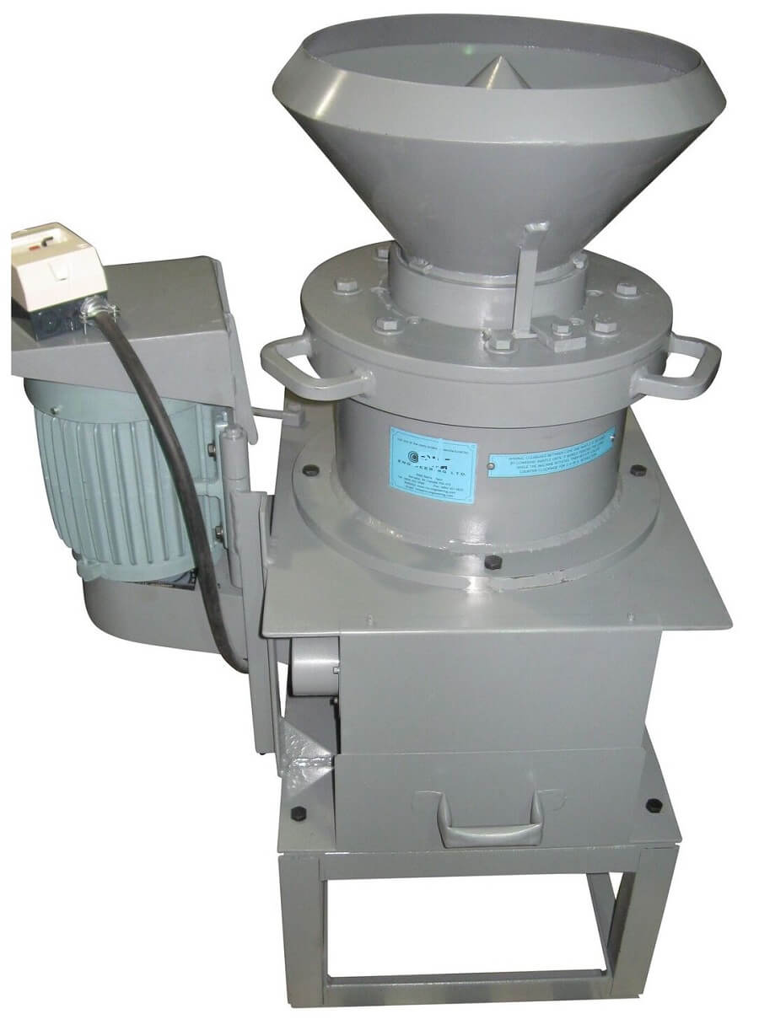

4.COMPOUND CONE CRUSHER: Compound cone crusher (VSC series cone crusher) can crush materials of over medium [hardness](https://en.wikipedia.org/wiki/Hardness). It is mainly used in mining, chemical industry, road and bridge construction, building, etc. As for VSC series cone crusher, there are four crushing cavities (coarse, medium, fine and superfine) to choose. Compared with the same type, VSC series cone crusher, whose combination of crushing frequency and eccentricity is the best, can make materials have higher comminution degree and higher yield. In addition, VSC series cone crusher’s enhanced laminating crushing effect on material particles makes the cubic shape of crushed materials better, which increases the selling point.

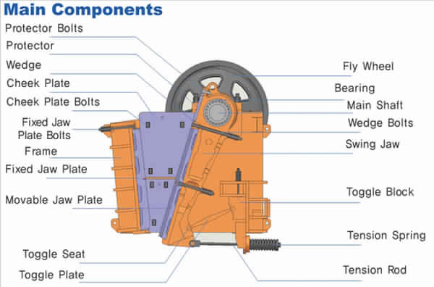

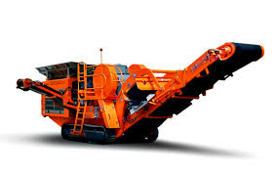

**Necessity**

* Projects like these are the need of the hour as we can see the extent of usage of plastic and other polluting/potentially harmful substances and the lack of proper waste management systems to compensate for such problems.
* Recycling of such materials is very important while at the same time is rather a challenging task.
* The most important problem is the space and volume required by these cups which can reduce the efficiency of recycling and more importantly demote it.
* While manual methods and other conventional type of conversions can be an increasingly tedious task, methods like these can solve this problem, thereby increasing the overall efficiency and decreasing time for such tasks.
* There’s also a need for easy transportation of waste cups from the site of generation to the site of recycling.
* To address such issues and to help create a better environment, such projects are most necessary thereby making the world a better place to live.

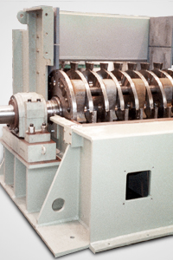

**Existing Solutions:**

Many attempts have been made to find solutions to above mentioned problems, a few are mentioned below;

1. The cup crusher which uses manual power of labourers. (https://youtu.be/PdGrTZt7FmU, n.d.)
2. Device which melts the plastic cups by maintaining a higher temperature in a closed vessel making it ready to recycle.
3. Hydraulic arms that crush the entire cup waste. (https://youtu.be/r0iLfAV0pIg, n.d.).
4. <https://youtu.be/CuKyVAz79UE>.
5. <https://youtu.be/47-b1BgzUo4>.

MATERIALS USED:

|  |  |  |  |
| --- | --- | --- | --- |
| SL NO | COMPONENTS USED | MECHANISM | LINKS |
| 1. | Arduino UNO | Microcontroller. | forum.arduino.cc |
| 2. | DC Motors | Electromagnetic Induction. | mechatronics.com |
| 3. | Battery | To store backup power using chemical energy. | mechatronics.com |
| 4. | Hard supporting base | To support against pressing arm | instructables.com |
| 5. | IC Circuits | To complete circuits for proper working. | mechatronics.com |
| 6. | Strong arms | To crush cups. | engineersgarage.com |
| 7. | Hard casing | To protect the inner mechanisms from external wear. | engineersgarage.com |